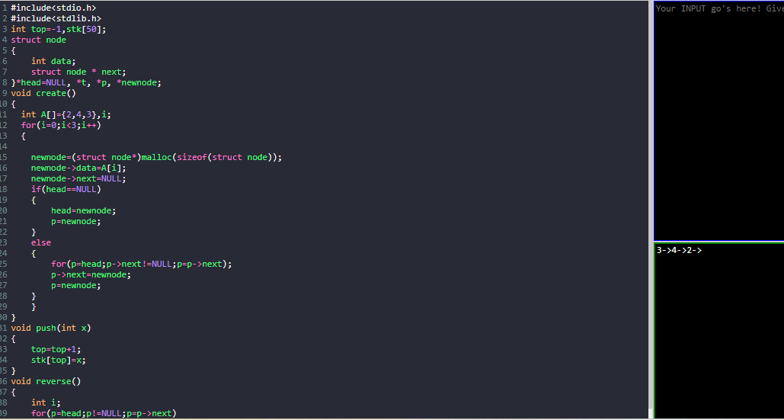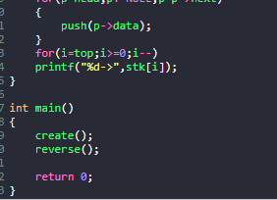#include<stdio.h>

#include<stdlib.h>

int top=-1,stk[50];

struct node

{

int data;

struct node \* next;

}\*head=NULL, \*t, \*p, \*newnode;

void create()

{

int A[]={2,4,3},i;

for(i=0;i<3;i++)

{

newnode=(struct node\*)malloc(sizeof(struct node));

newnode->data=A[i];

newnode->next=NULL;

if(head==NULL)

{

head=newnode;

p=newnode;

}

else

{

for(p=head;p->next!=NULL;p=p->next);

p->next=newnode;

p=newnode;

}

}

}

void push(int x)

{

top=top+1;

stk[top]=x;

}

void reverse()

{

int i;

for(p=head;p!=NULL;p=p->next)

{

push(p->data);

}

for(i=top;i>=0;i--)

printf("%d->",stk[i]);

}

int main()

{

create();

reverse();

return 0;

}